**Image Segmentation using k-means :**

**(1) Reshape our image :**

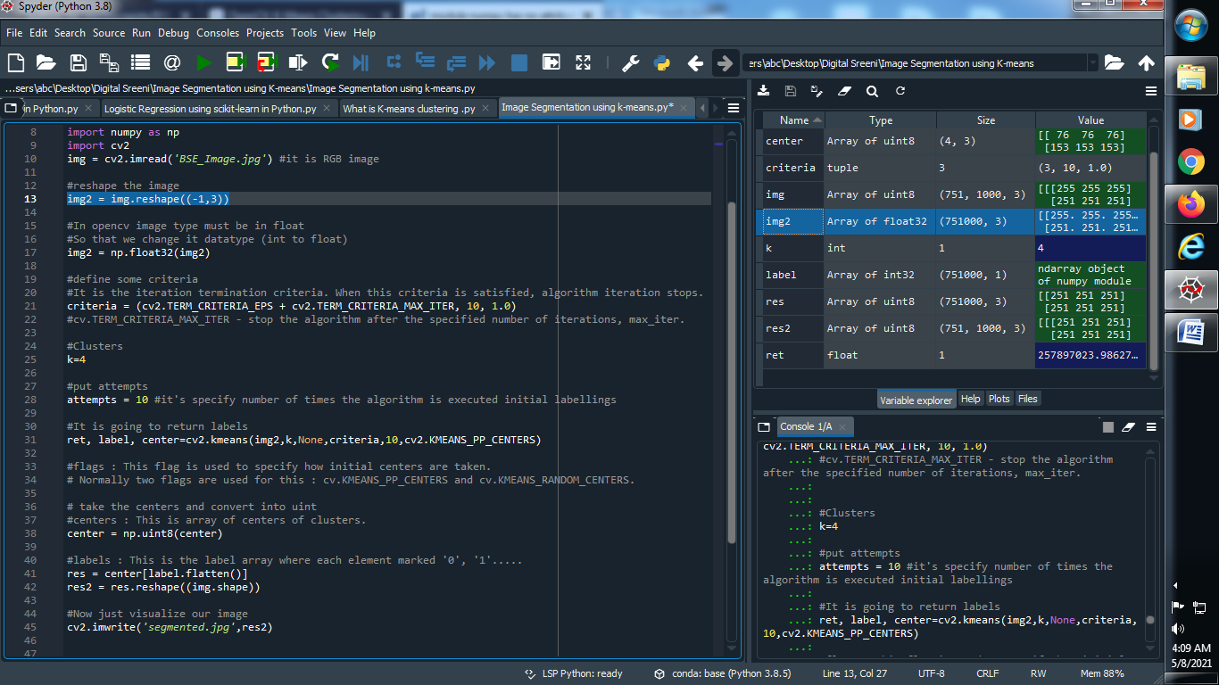

**Output :**



**(2) Change data type of image :**

**Note : In Opencv image must in float so we reshape our image int to float..**

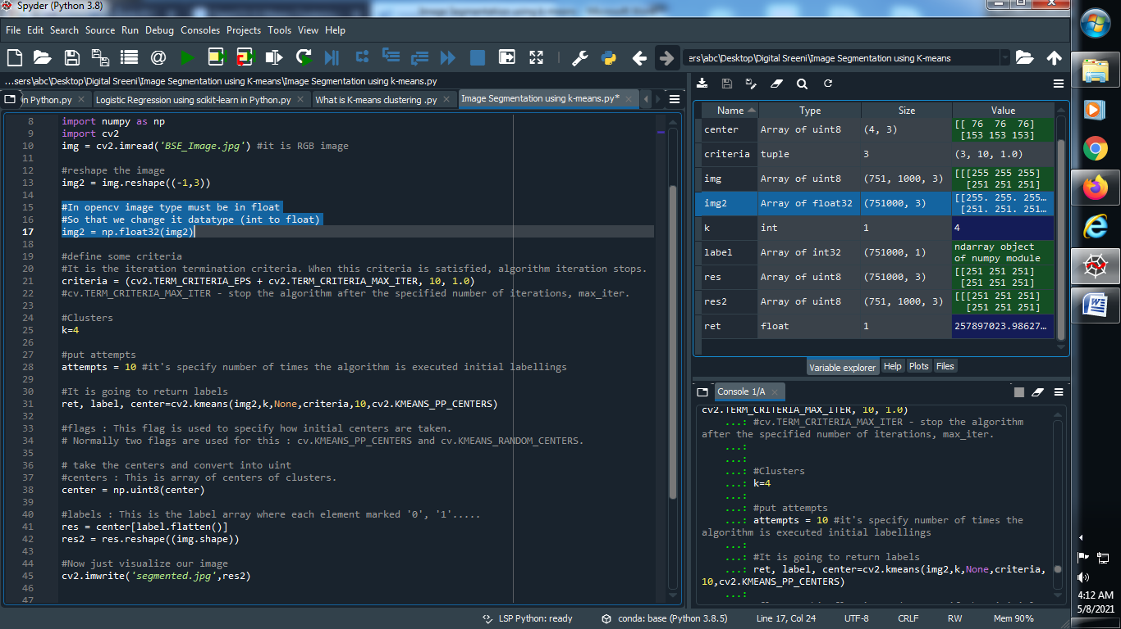

**Output :**



**(3) Define some criteria :**

**Note : criteria means iteration termination ..when this criteria is satisfied, algorithm iteration stops.**

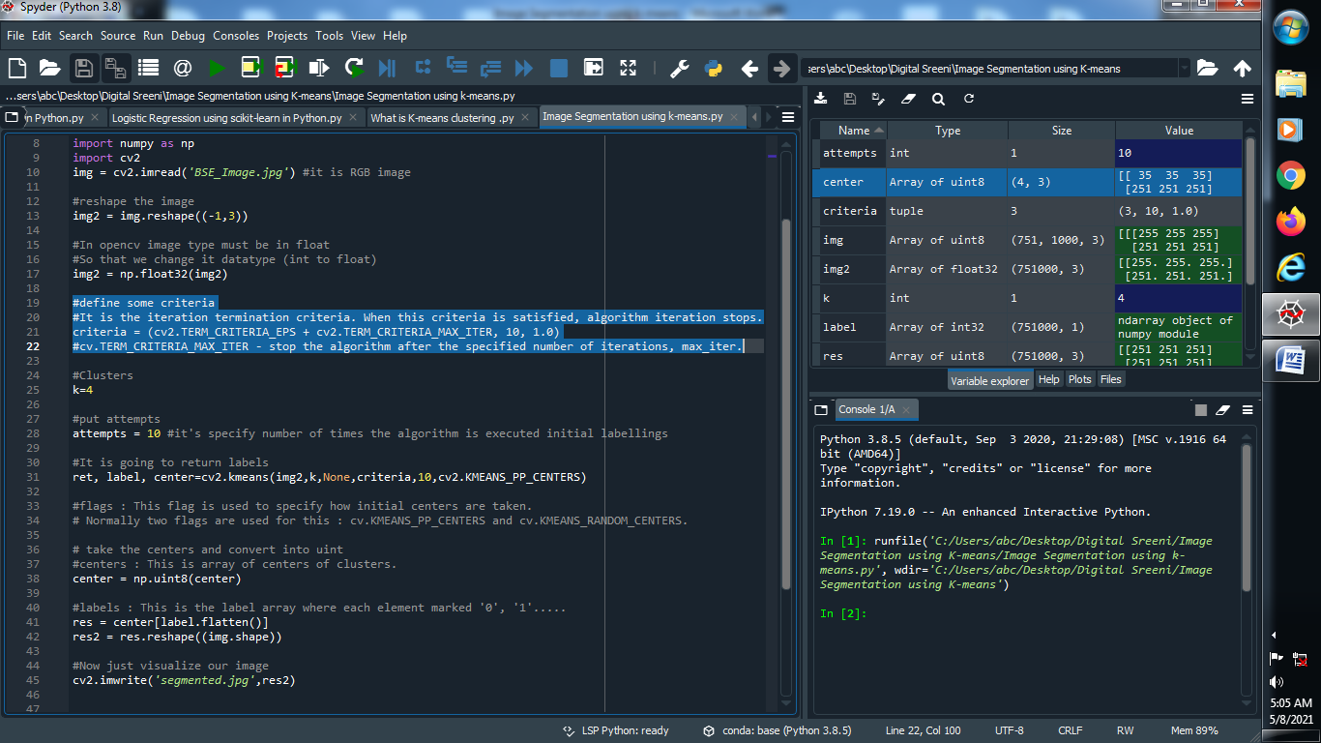

**Output :**



**(4) Assign the clusters and put attempts :**

**Note : attempts means it’s specify number of times the algorithm is executed initial labelings .**

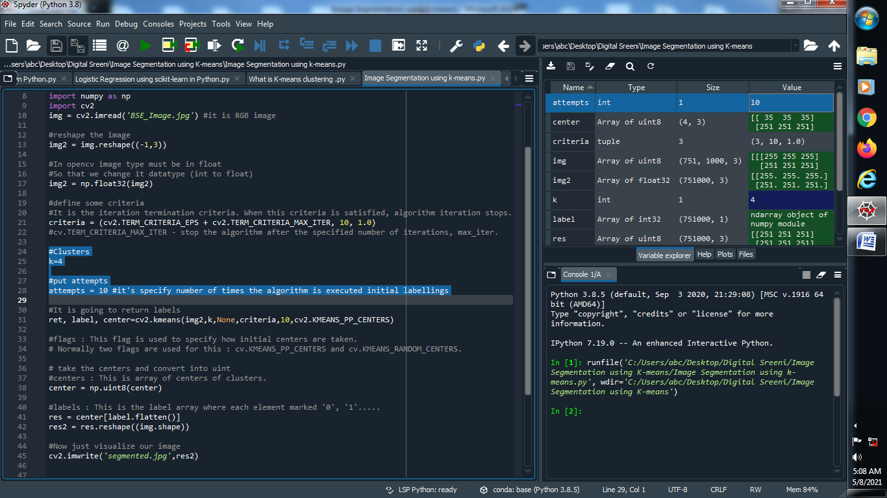

**Output :**



**(5) Return labels :**

**Note : flags means it is flag is used to specify how initial centers are taken.**

**Normally two flags are used for this : cv.KMEANS_PP_CENTERS and cv.KMEANS_RANDOM_CENTERS.**

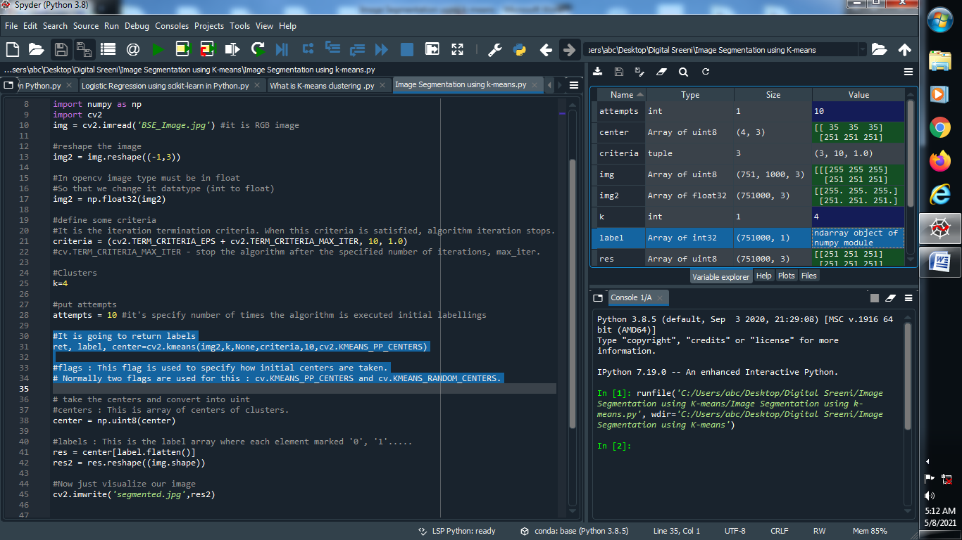

**Output :**



**(6) Assign center :**

**Note : Center means it is the array of centers of clusters.**

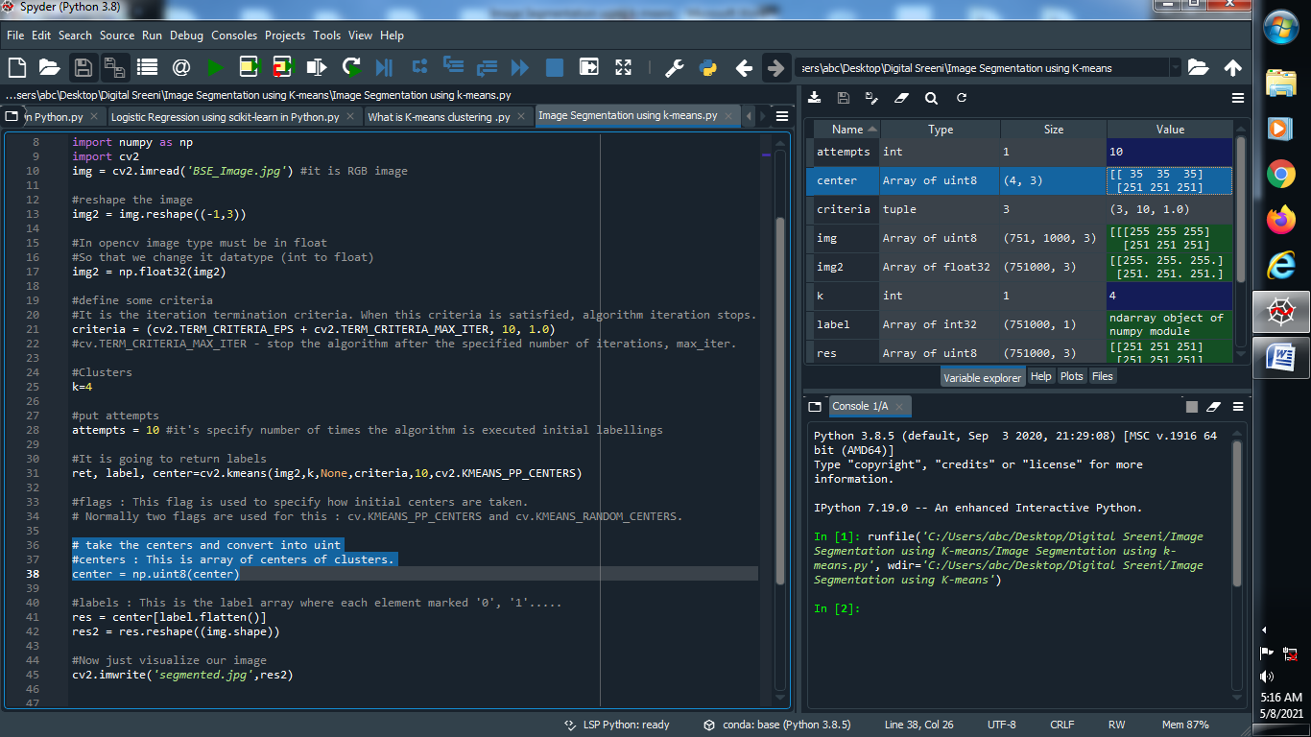

**Output :**



**(7) Assign label and reshape our image :**

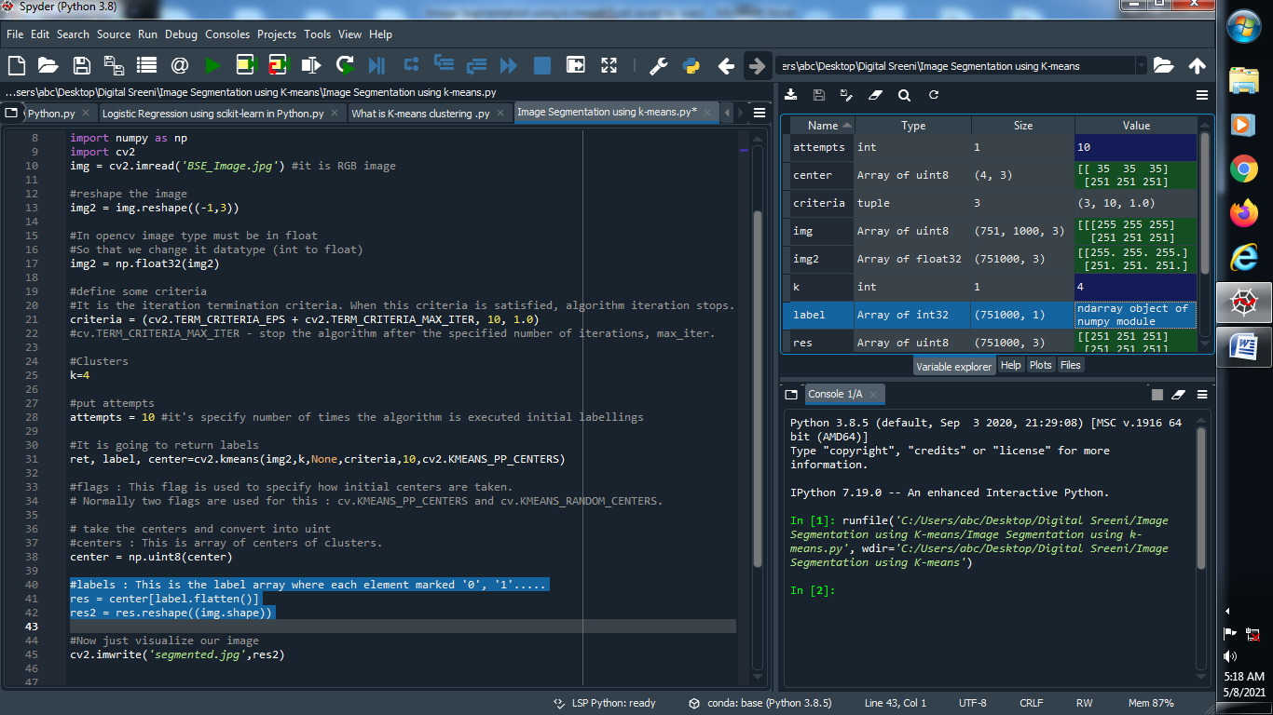**]**

**Output :**



**(8) Now visualize our segmented image :**

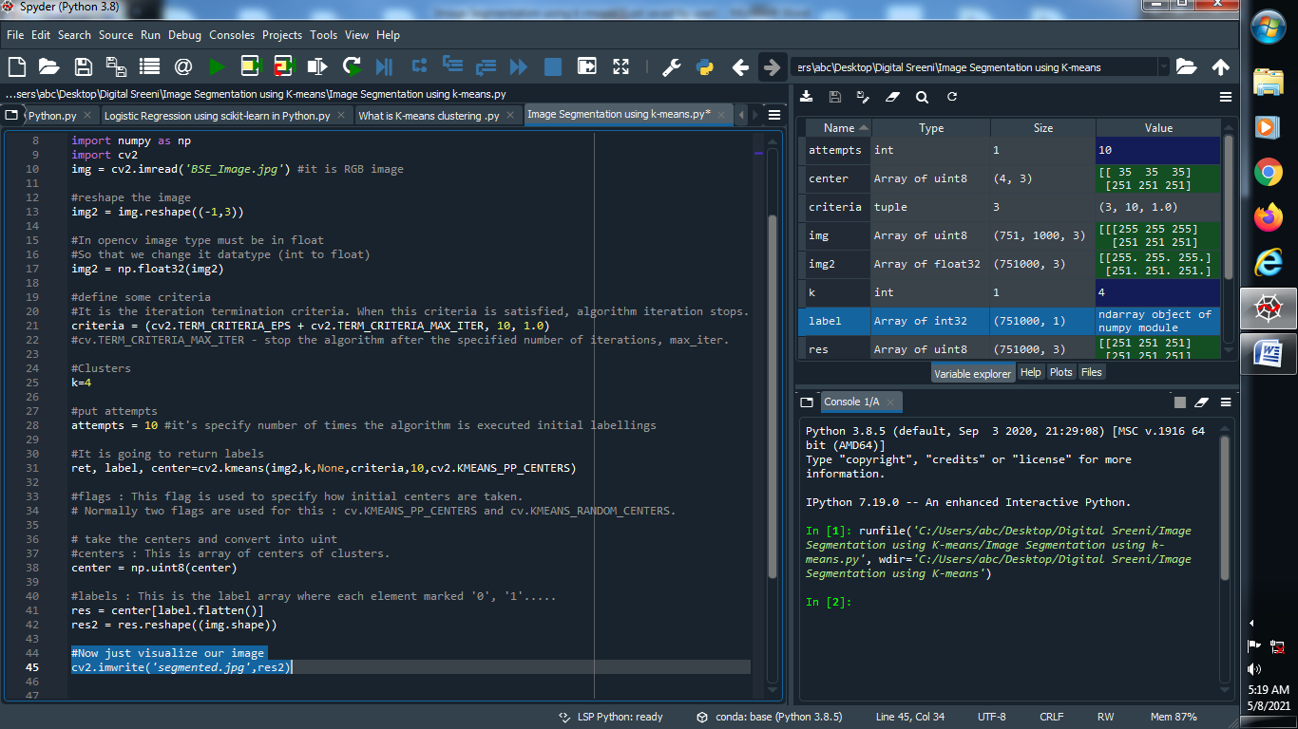

**Output :**

**Main Image : Segmented Image :**

